Topic: Typing on a Computer Keyboard
When I am done this lesson, I will know:
- How a keyboard works
- How to type properly using a keyboard on a computer

Pre and Post Self-Assessment
 | Pre | Pre | Post | Post
 | Yes, I know this | No, I want to learn this | Yes, I know this | I still need more practice to learn this
I know what the keyboard is on a computer
I know how to type properly on a computer keyboard


New Words and Terms
QWERTY
typewriter
key
circuit
What is a Keyboard?
A keyboard is the panel of keys that you use to operate or tell the computer what to do. It allows you to input information into the computer.
The most common kind of keyboard is called a ‘QWERTY’ keyboard. It is named after the first six keys in the top row of letters. It was invented by C L Scholes in the 1860s and was first found on a typewriter. Typewriters were very expensive and keys that were used a lot would clump together. To avoid one spot wearing out all the time or clumping together, different arrangements of keys were tested. The layout that became the most common because it prevented keys from clumping together or wearing out was the QWERTY keyboard. Modern keyboards have the same layout as typewriters. There is another keyboard layout called the Dvorak keyboard which has all the vowels on the second row. This is much less commonly used today.
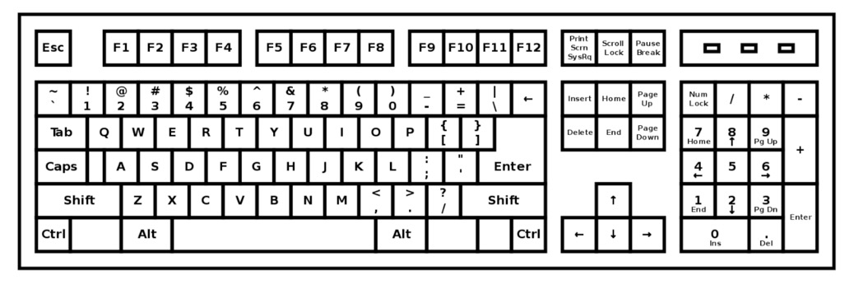
How Does a Keyboard Work?
A keyboard is like a miniature computer. It has its own processor and circuitry that carries information to and from that processor. The key matrix is a grid of circuits underneath the keys. Each circuit is broken at a point below each key. When you press a key, it presses a switch, completing the circuit and allowing a tiny amount of current to flow through. If you press and hold a key, the processor thinks you are pressing a key repeatedly.
When you press a key, the processor finds the closed circuit and compares the location of that circuit on the key matrix to the character map in its memory. A character map is a comparison chart or look-up table. It tells the processor the position of each key in the matrix and what each keystroke or combination of keystrokes represents. For example, the character map lets the processor know that pressing the “a” key by itself produces a small letter a, but the “Shift” key and “a” key pressed together produce a capital A.
Source of How a Keyboard Works: adapted from https://computer.howstuffworks.com/keyboard2.htm (last accessed April 15, 2019)

Most keyboards will look like the one in the diagram below. However, some of the keys may be in different spots depending on the computer. For example, most laptops do not have a separate number pad like the diagram below does.
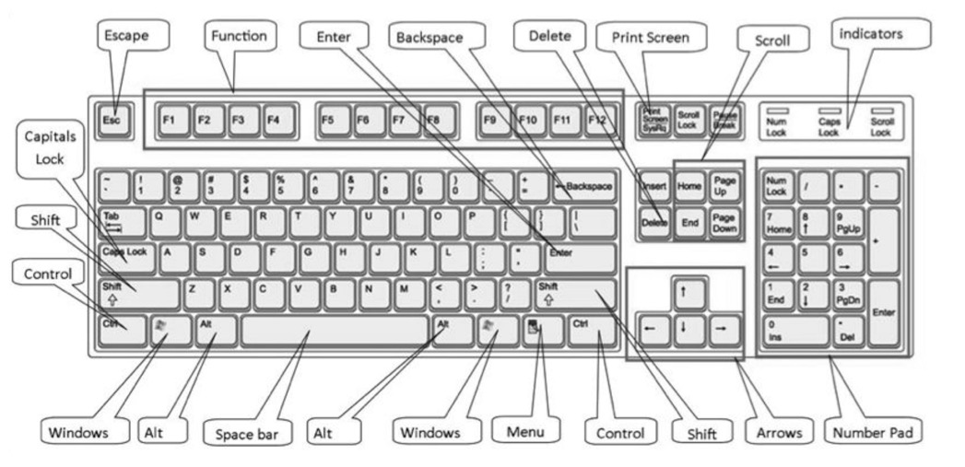
Important Sections and Keys on the Keyboard
Source: https://www.digitalunite.com/sites/default/files/images/keyboard850.jpg
Note: You can use this link to download and print the keyboard diagram above.
Some Keyboarding Basics
The main keys are the letter keys. When you type just using these, you get lower-case print. However, if you hold down a “shift” key (there are two – one on the left and one on the right) at the same time as you type, you’ll get UPPER-CASE letters. This also lets you type the symbols you see above the numbers.
If you make a mistake when you type, it is easy to fix.
If you want to delete a letter, place your cursor (mouse pointer) just after the letter and click. Then press Backspace. Only press once or it will keep deleting.
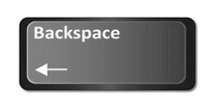
Or
Place your cursor just before the letter, click and press Delete.
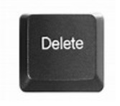
You can move the cursor along a sentence without deleting anything by using the arrow keys:
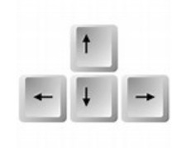
Source: https://www.digitalunite.com/technology-guides/computer-basics/using-computer/how-usecomputer-keyboard

Check Your Knowledge
What is the name of the most common type of keyboard?

The best way to learn how to type on a computer keyboard properly is to practice. GCFGlobal has a typing tutorial that will allow you to learn how to type on a QWERTY keyboard. This tutorial has several sections and will take a few weeks to complete. Typing.com allows you to set up a free account that saves your progress as you learn to type.


Try this/Practice
Use this interactive tutorial to learn to type on a QWERTY keyboard. | Source: GCFGlobal.org  https://edu.gcfglobal.org/en/typing/
Or
Sign up for a free account on Typing.com. You can use this site to learn how to type, take tests and play typing games. The account will save your progress. | https://www.typing.com/

Optional: I Want to Learn More
Click on the links below to practice typing using a variety of free games.
Type for Your Life: https://games.sense-lang.org/type4life/
Typing Alien: https://games.sense-lang.org/typingAlien.php
Typing Long Jump: https://games.sense-lang.org/longJump.php
Kayak Game: https://games.sense-lang.org/kayak/
Typing Olympic: https://games.sense-lang.org/olympic/
Balloon: https://games.sense-lang.org/EN_BalloonG.php
Chameleon: https://games.sense-lang.org/EN_ChameleonG.php


Ontario Adult Literacy Curriculum Framework Connection
Competency | Task Group(s)
Find and Use Information | - Read Continuous Text (L3)  - Interpret Documents (L2 - keyboard)  - Extract Information from Films, Broadcasts and Presentations (not levelled)
Communicate Ideas and Information | - Complete and Create Documents (L2- make entries using limited range of vocabulary)
Using Digital Technology | - Follow Simple Prompt (L1)  - Use Basic Word Processing Software  - Create a New User Account (L2)



